This document is for recording your file-naming schemas and folder structures developed in the Naming and organizing your files and folders worksheet. This example README includes descriptions and examples for your guidance. See the README: File & Folder Schema (Template) for a blank version.

For guidance on creating readmes to document information on datasets, see: Guide to writing "readme" style metadata. Cornell Research Data Management Service Group. https://data.research.cornell.edu/content/readme

Overview:

Project/Lab Name: Name the project for which this file organization documentation refers. If it documents the organization schema for a research/lab group, include that here.
Ex: Our Lab, Project 123

Creator: Who created the file organization schema? This is important information as a user may need to get clarification, suggest a revision of the schema, etc. Include the institution/address/email for contacting this person.
Ex: MIT LIbraries Data Management Services, data-management@mit.edu

Owner: This may be the same as the creator, but you should indicate who is currently responsible for maintaining this file organization schema? This person can change as people leave/arrive. Again, include institution/address/email for contacting this person.
Ex: Christine Malinowski, cmalin@mit.edu

Date of last update: Indicate when the last changes of this schema were made. In some instances, it may be useful to keep a log of the revision history.
Ex: 2018.02.12
Revision History Ex:
Date Person who made revision Notes on revision
2018.02.12 Christine Malinowski added example content
2018.01.31 File org project group created README document

Files location: Where are the files referenced here kept? Include a file path so people can easily find the necessary files. If there are permission restrictions, you may also want to include that information.
Ex: dropbox/ourLab/project123/

README location: Include the file path for this particular README. This may seem superfluous, but often READMEs are shared outside of their home location (e.g., via email), so it’s good to indicate where the README can be found.
Ex: dropbox/ourLab/project123/documentation/

Folder structure:

Sketch out here or insert a screenshot of your folder structure. Note, if including a screenshot, expand all folders to show the full hierarchy.

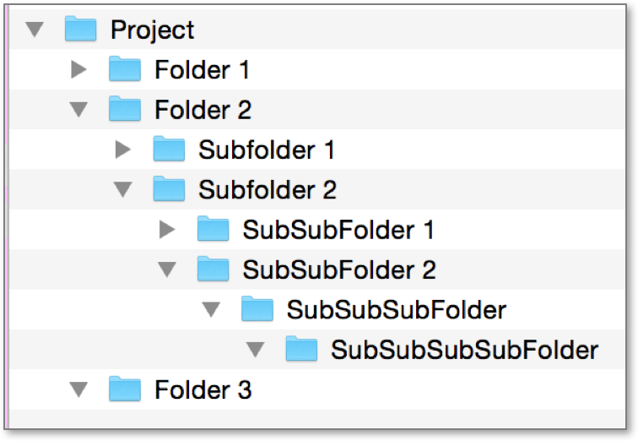

File naming schema:

File type: Microscope image
Filename schema: [date]_[microscope]_[imageNumber]
Schema key: date: date of image capture in YYYYMMDD format
microscope: name/model of microscope used
imageNumber: written in sequential formatting 00X - XXX
Example filename: 20180118_mic53_001.jpg

Repeat this information for each of your file types.

File type:
Filename schema:
Schema key:
Example filename:

File type:
Filename schema:
Schema key:
Example filename:

File type:
Filename schema:
Schema key:
Example filename:

You can also document this information in a table:

File type | Filename schema | Schema key | Example filename
Microscope image | [Date]_[microscope]_[imageNumber] | Date: Date of image capture in YYYYMMDD format  microscope: name of microscope used  imageNumber: written in sequential formatting 00X | 20180118_mic53_001.jpg

Filename abbreviations

Use this section to document any abbreviations used in the file-naming schemes described above.

Filename descriptor | Abbreviations key
Ex: Location | ATL: Atlanta  BOS: Boston
Ex: Microscope (name) | mic53: microscope 53, located in room 1...

Save your README file as a plain text file (nonproprietary file format) and store in a location accessible to all members of your group. Revisit and revise it as necessary.

We’d be honored for you to reuse or link to our content, but we’d appreciate it if you’d credit the MIT Libraries as the source.

Please cite as:
README: File & Folder Schema Example by MIT Libraries Data Management Services. Copyright © 2018 MASSACHUSETTS INSTITUTE OF TECHNOLOGY, licensed under a Creative Commons Attribution 4.0 International License except where otherwise noted. [https://creativecommons.org/licenses/by/4.0/]. Access at https://www.dropbox.com/s/ritd1mwzyaz2dh6/Sample_README_fileOrg.docx?dl=0.

Please respect the licenses and copyrights of all materials cited in this handout.

